**USER’S**

**MANUAL**

# LEVA

Version 1.0

## USER'S MANUAL

**TABLE OF CONTENTS**

Page #

### *1.0* *GENERAL INFORMATION ..................................................................................................... 1-1*

**1.1** **System Overview .................................................................................................................... 1-1** **1.2** **Organization of the Manual .................................................................................................. 1-1**

### *2.0* *SYSTEM SUMMARY ................................................................................................................. 2-1*

**2.1** **System Configuration ............................................................................................................ 2-1** **2.2** **User Access Levels ................................................................................................................. 2-1** **2.3** **Contingencies .......................................................................................................................... 2-1**

### *3.0* *GETTING STARTED ................................................................................................................. 3-1*

#### 3.1 Installation………………............................................................................................................ 3-1 3.2 System Menu ................................................................................................................................. 3-1

3.2.1 Search tab ................................................................................................................................................. 3-1

3.2.2 Import tab ................................................................................................................................................. 3-2

3.2.3 Database tab ............................................................................................................................................. 3-3

3.2.4 Settings tab ............................................................................................................................................... 3-4

**3.4** **Exit System .................................................................................................................................... 3-5**

***4.0*** ***USING THE SYSTEM .................................................................................................................. 4-1***

4.1.1 Search tab ................................................................................................................................................ 4-1

4.1.2 Import tab ................................................................................................................................................ 4-1

4.1.3 Database tab ............................................................................................................................................ 4-1

4.1.4 Settings tab .............................................................................................................................................. 4-2

### 1.0 GENERAL INFORMATION

### 1.0 GENERAL INFORMATION

General Information section explains in general terms the system and the purpose for which it is intended.

### 1.1 System Overview

LEVA is application, which allows importing articles and analyze the information about the sentence structure. The application saves data collected to database. The application suggests word association with the support of sample sentences collected from imported articles for user to reference. Its operational status is under development. LEVA operates PC with Windows operating system.

### 1.2 Organization of the Manual

The user’s manual consists of five sections: General Information, System Summary, Getting Started, Using the System, and Reporting.

General Information section explains in general terms the system and the purpose for which it is intended.

System Summary section provides a general overview of the system. The summary outlines the uses of the system’s hardware and software requirements, system’s configuration, user access levels and system’s behavior in case of any contingencies.

Getting Started section explains how to get LEVA and install it on the device. The section briefly presents system menu.

Using the System section provides a detailed description of system functions.

Reporting section describes in what way information collected by the application are presented and how to access the information.

**2.0 SYSTEM SUMMARY**

### 2.0 SYSTEM SUMMARY

System Summary section provides a general overview of the system. The summary outlines the uses of the system’s hardware and software requirements, system’s configuration, user access levels and system’s behavior in case of any contingencies.

### 2.1 System Configuration

LEVA operates on desktop computer with Windows operating system. It is compatible with Window 10 or higher version. The application does not require connection to Internet. All the file would be saved in local file system including the database and the file of articles. After installation on the device, LEVA can be used immediately without any further configuration.

**2.2 User Access Levels**

Everyone can use application, including modification on the records storing in the database.

### 2.3 Contingencies

In case of power outage, if the data is writing to database during importing the articles, the files and the database maybe corrupted. User can recover the data from backup file or default file by using the recovery function provided by the application.

**3.0 GETTING STARTED**

### 3.0 GETTING STARTED

Getting Started section explains how to get LEVA and install it on the device. The section presents briefly system menu.

### 3.1 Installation

The newest installation version currently available on the GitHub and transmit internally. It is a .exe file. For specific instruction on how to install application on specific device refer to device’s manual. Associated module needed for the application would be installed as well during installing the application.

### 3.2 System Menu

LEVA is tabbed application, which consists of 4 tabs (Figure 1). These tabs represent categorized the function of this application. Home tab containing the page of searching function. Import tab containing the importing function. The Database tab displaying the record storing the database while the last tab provides some function related to the system.



**Figure 1. Tabs of LEVA**

#### 3.2.1 Search tab

The Search tab (Figure 2) consists of 6 input fields basically. It allows the user to search the keyword by filter, which is the keyword, its part-of-speech, its dependency, the results’ part-of-speech, threshold (ignore the result if its frequency is below the number) and the words that would be ignore (those words would not be shown in the result list).

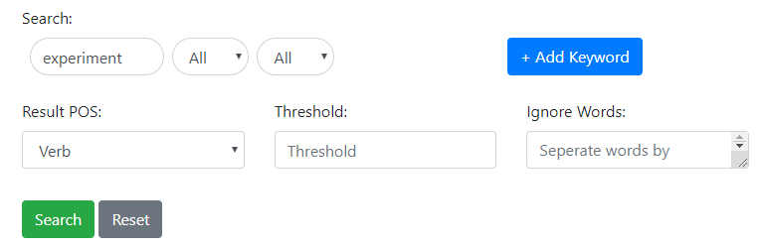

**Figure 2. Search tab with one keyword**

The Search tab (Figure 2) allows the user to search by multiple keywords by clicking the “Add keyword” button.

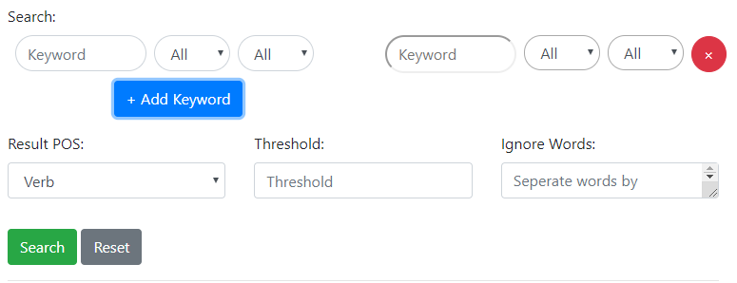

**Figure 3. Search tab with multiple keywords**

The Search tab will show the result of words used associated with the keywords searched sorted by frequency in ascending order. (Figure. 3, Figure. 4). Moreover, user can enter type part of the words to filter out the result. (Figure. 5)

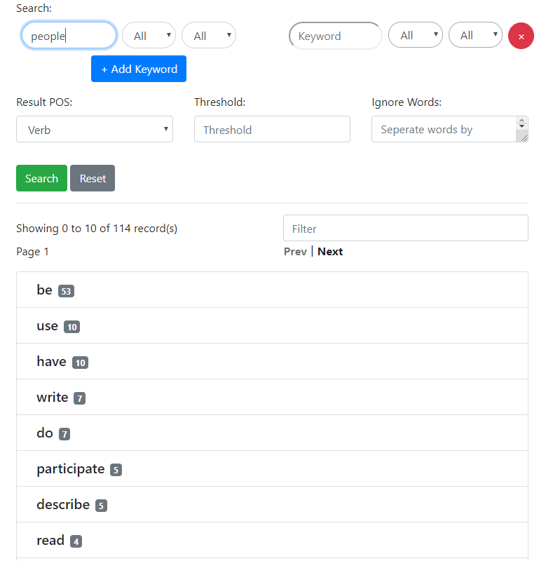

**Figure 4. Search tab with the result list (Excerpted)**

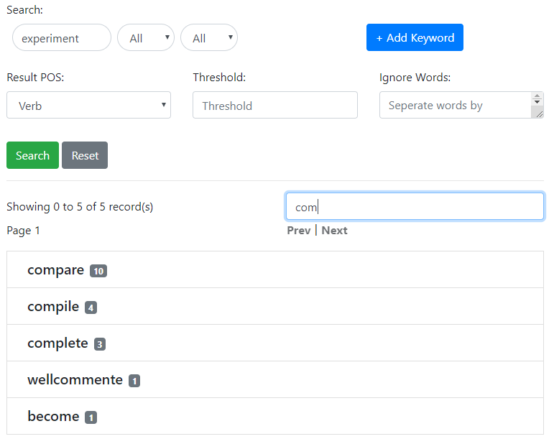

**Figure 5. Showing filter function of result (Excerpted)**

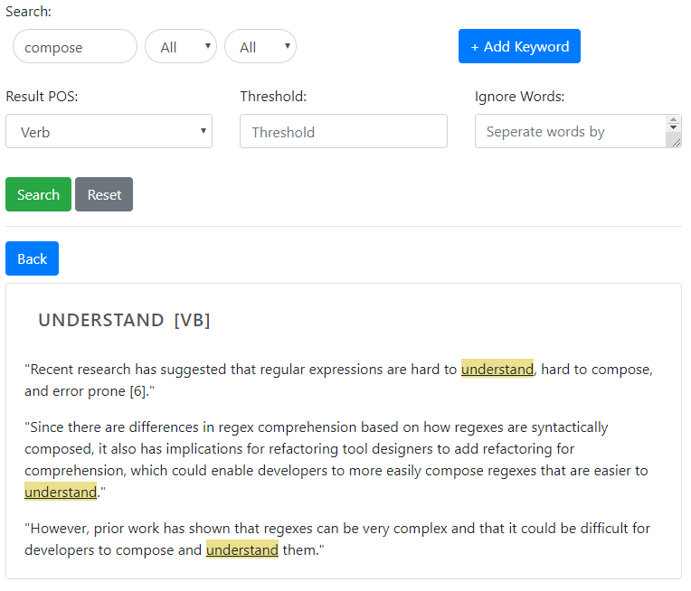

**Figure 6. Search tab with word’s detail (Excerpted)**

User can click into the word and see the example of usage (Figure. 6). The targeted word would be highlighted in each example sentence.

#### 3.2.2 Import tab

The Import tab (Figure 7) allows the user to import pdf file (only one or multiple file at a time). User can check the checkbox to ignore incomplete sentences automatically. A progress bar would be shown to show the parsing progress (Figure 8).

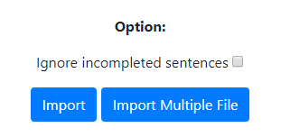

**Figure 7. Import tab (Step 1)**



**Figure 8. Import tab (Step 2 progress bar)**

The parsed result (Figure. 9) would be shown once the parsing process have finished. The user can choose to ignore specific sentences. Click the import button to store the sentences to the database or click cancel button to leave.

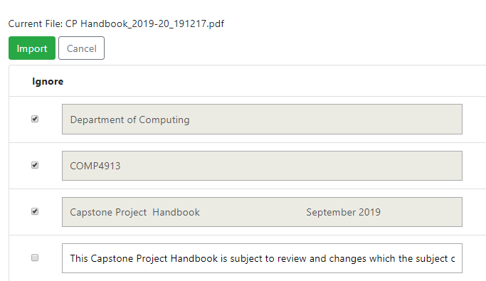

**Figure 9. Import tab (Step 2 Parsed result, single file)**

For importing multiple files at a time (Figure. 10), the user must choose to import pdf one by one. Click import button to import the current file, click delete button to discard the current pdf file, or click cancel to leave the importing process.

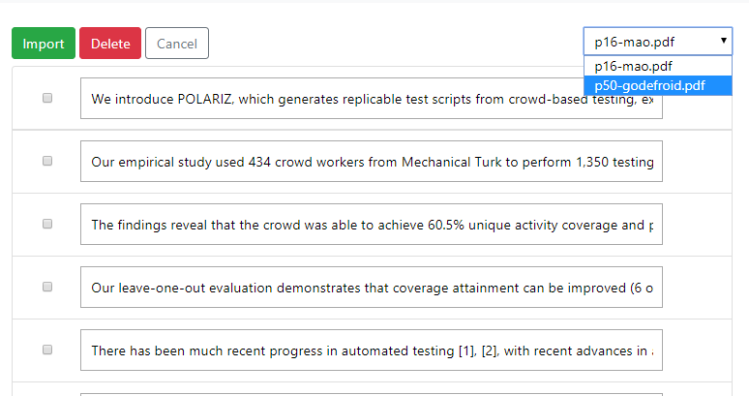

**Figure 10. Import tab (Step 2 Parsed result, multiple file)**

#### 3.2.3 Database tab

The Database tab (Figure 11) allows the user to browse, modify or delete specific record in database.

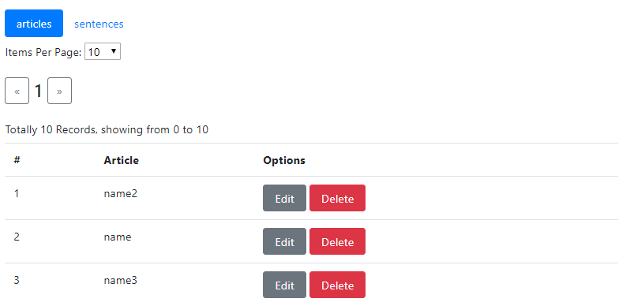

**Figure 11. Database tab**

#### 3.2.4 Settings tab

The Setting tab (Figure 12) allows to handle the database by resetting, restoring the database or making a backup.

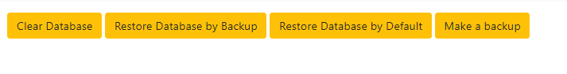

**Figure 12. Settings tab**

**3.4 Exit System**

LEVA can be closed by clicking the closed button on the top of the browser.

**4.0 USING THE SYSTEM**

### 4.0 USING THE SYSTEM

This section provides a detailed description of system functions.

#### 4.1.1 Search tab

The search consists of 6 input fields initially containing basic information about the keyword(s), its POS tagging, its dependency, POS tagging of result words, threshold and ignore word.

Keyword(s) and ignore word are text field. POS tagging of keywords and result are dropdown menu and the threshold is numeric input fields.

After inputting the searching information and click the search button. A list of word matching the criteria would be shown. You can type in some character in the filter field to narrow down the result list.

Then, you can click on a word to see how they are used. There would be a list of example sentences, which was extracted from the pdf file imported before, containing the target word. If the target word has different form (single form VS plural form for Noun or present tense VS past tense for Verb), The result would be grouped and separated for better referencing purpose.

#### 4.1.2 Import tab

If you want to compose the database by yourself, you need to use this function.

The Import tab consist of two button and a checkbox at the beginning. Import single file button, import multiple file button and option of ignore incomplete sentence.

If you want to import one pdf file only, you need to click the “import single file” button and select the pdf file. Then the parser will start running. After that, the parser would split the article into sentences. But it usually not very well or there are some sentences that you don’t want to import. Hence you can choose to ignore some sentences or modify them. Finally, you can click the import button to import the pdf to be one part of the database. You will confirm message whatever this action is success or not. Or you can click cancel to give up importing the file.

If you want to import multiple pdf file at the same time, you need to click the “import multiple file” button and select the pdf files. Then the parser will start running. After that, the parser would return a dropdown box containing the name of the articles. You can modify or choose to ignore the sentences for each pdf file individually. You can click the cancel to give up importing the files, click the delete button to give up the current file or click the import button to import the current file. Once all the files are given up or imported, import tab will prompt a message and go back to the initial state.

#### 4.1.3 Database tab

The database tab contains two inner-tabs, “articles” and “sentences” and a table.

When entering the tab for the first time, the table of articles will be shown in default. You can see the “articles” tab is highlighted in blue color. In the table, the id and the name of each record stored in the table would be shown. You can edit the name or delete the record.

If you want to browse the record of sentences, you can simply click the “sentences” to switch from the table of articles to sentences. You can see the initially sentences, dependency, word list, pos tagging here, and a delete button for each record. You can only delete instead of modifying them.

Each page will show 10 entries in default. There is a dropdown box that you can choose to show 10, 25, 50 or 100 entries each page.

#### 4.1.4 Settings tab

The Setting tab allows to handle the database content. There are four buttons: Clean the database, make a backup, restore the database from backup, and restore the database from default file.

Initially, there are totally 114 articles and 27883 sentences storing in the current database file and the default database file. You can store more articles and sentences by using the import function. You can backup the current database file by clicking the button “make a backup”.

If you want to restore from the save file, you can click the “restore the database from backup” and it will roll back to the state which was backup by you before.

If you want to reset the database, you can click the “restore the database from default” and it will roll back to the initial database file (containing 114 articles and 27883 sentences).

If you want to build the database from zero. You can choose to click the “reset the database” button, it will remove all the record storing in the database.